
RAJALAKSHMI ENGINEERING COLLEGE, CHENNAI
Department of Artificial Intelligence & Data Science

EXPERIMENT 5
Cloud Migration – Backup Setup Using Google Drive as the Cloud Storage Service

Aim
To create a cloud backup system by storing important files in Google Drive, scheduling automatic backups, and verifying successful backup completion.

What Is Cloud Backup?
Cloud Backup means storing a copy of your important files on cloud servers instead of keeping them only on your computer.

Example
Without Backup:
Laptop
|
Important Files
If the laptop crashes, the files may be lost.
With Cloud Backup:
Laptop
|
v
Google Drive
Even if the laptop fails, the files remain safe in the cloud.

What Is Cloud Migration?
Cloud Migration means moving your files, applications, or data from your local computer to a cloud service.

Example
Computer
|
v
Google Drive

Requirements
- Windows 10 / 11
- Google Account
- Internet Connection

Part A – Create Sample Data

Step 1: Create a Folder
Create a folder on the Desktop and name it OfficeData.

Step 2: Create Sample Files
Inside the folder, create three text files and add some sample content to each:
- Student.txt
- Attendance.txt
- Marks.txt
Example content:
Student.txt
Name : Student
Department : AI & DS

Attendance.txt
Attendance : 95%

Marks.txt
Cloud Computing : 98
The folder structure now looks like:
OfficeData
|-- Student.txt
|-- Attendance.txt
'-- Marks.txt

Part B – Create Cloud Storage

Step 3: Sign In to Google Drive
1. Open https://drive.google.com
2. Log in with your Google account.

Step 4: Create a Backup Folder
1. Click “+ New.”
2. Choose “Folder.”
3. Name it CloudBackup and click Create.

Part C – Upload Files

Step 5: Upload the Sample Files
1. Open the CloudBackup folder.
2. Click “+ New” → “File Upload.”
3. Select all three files (Student.txt, Attendance.txt, Marks.txt).
4. Click Open to begin the upload.
Google Drive uploads the files. The folder now contains:
Google Drive
CloudBackup
|-- Student.txt
|-- Attendance.txt
'-- Marks.txt
Congratulations — you have migrated your files to the cloud.

Part D – Install Google Drive for Desktop

Step 6: Download and Install
1. Open https://www.google.com/drive/download/
2. Download Google Drive for Desktop.
3. Install the application.
4. Log in using the same Google account.

Part E – Enable Folder Synchronization

Step 7: Configure Sync
1. Open Google Drive Settings.
2. Click Add Folder and select Desktop → OfficeData.
3. Enable “Sync with Google Drive.”
4. Click Done.
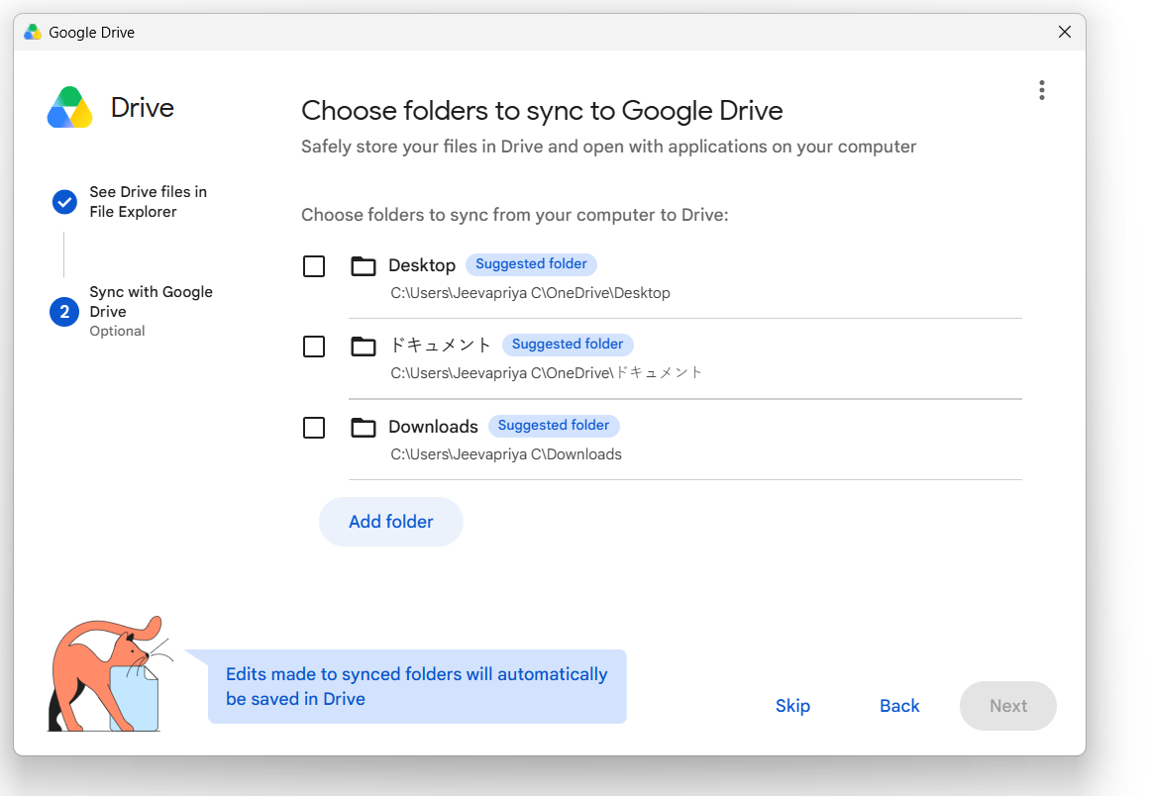
Figure 1: Selecting a folder to sync with Google Drive.
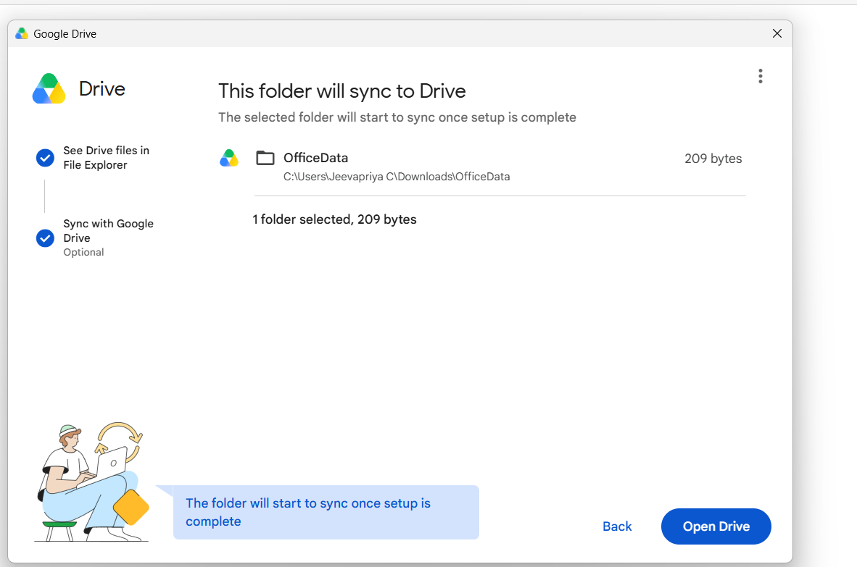
Figure 2: Confirming the OfficeData folder for synchronization.
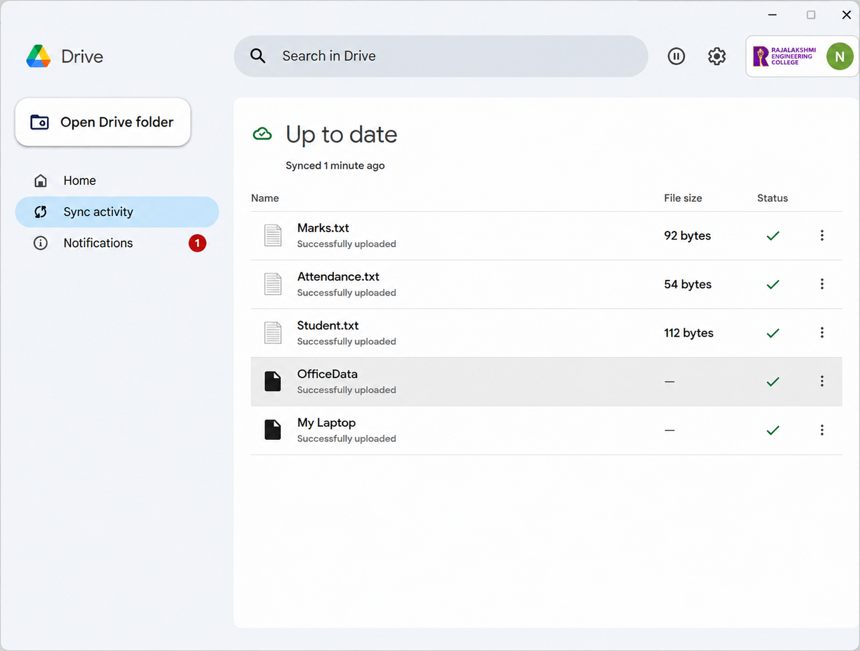

Figure 3: Google Drive desktop app showing all files successfully uploaded.
Part F – Test Automatic Backup

Step 1: Verify the Files in the Cloud
Click "Open Drive on the web" to open Google Drive in the browser, then locate the folder containing the synchronized files. It should contain:
OfficeData
|-- Marks.txt
|-- Attendance.txt
'-- Student.txt
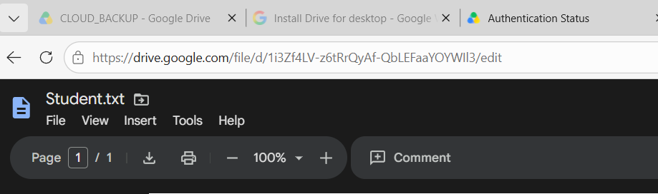
Figure 4: Synchronized OfficeData files visible in Google Drive on the web.

Step 2: Perform the Backup Test
Now confirm that automatic backup works:
1. Go back to the local OfficeData folder.
2. Open Student.txt.
3. Add the following line at the bottom of the file:
Cloud Backup Test - Successfully Synchronized
4. Save the file.

Step 3: Wait for Synchronization
Wait about 10–30 seconds, then open the Google Drive application again. The file status should change to:
Successfully uploaded / Up to date ✓

Step 4: Verify from Google Drive Web
1. Refresh Google Drive in the browser.
2. Open Student.txt.
The file should now display the new line:
Cloud Backup Test - Successfully Synchronized
This confirms that a change made to the local data was automatically backed up to the cloud.
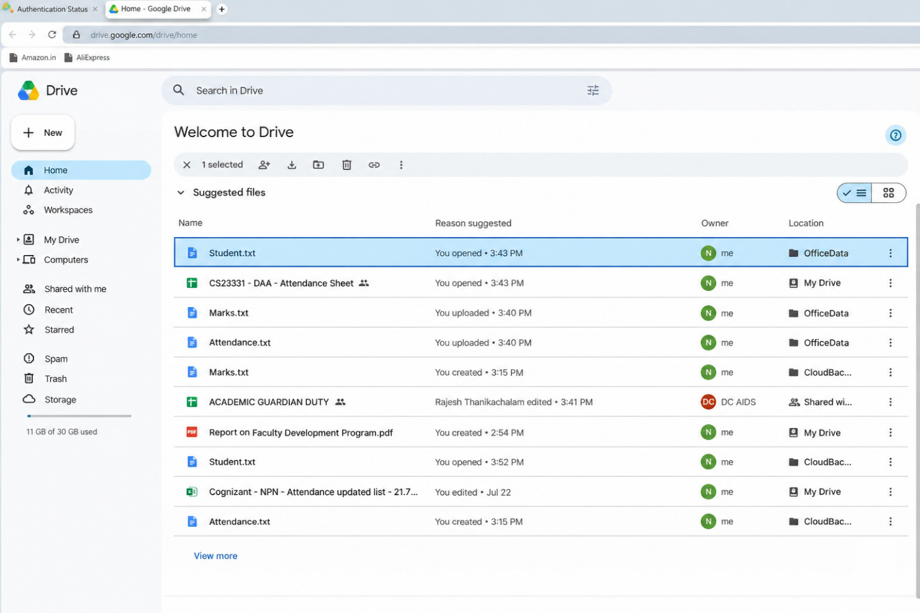

Figure 5: Google Drive web view showing Student.txt with a recent update.
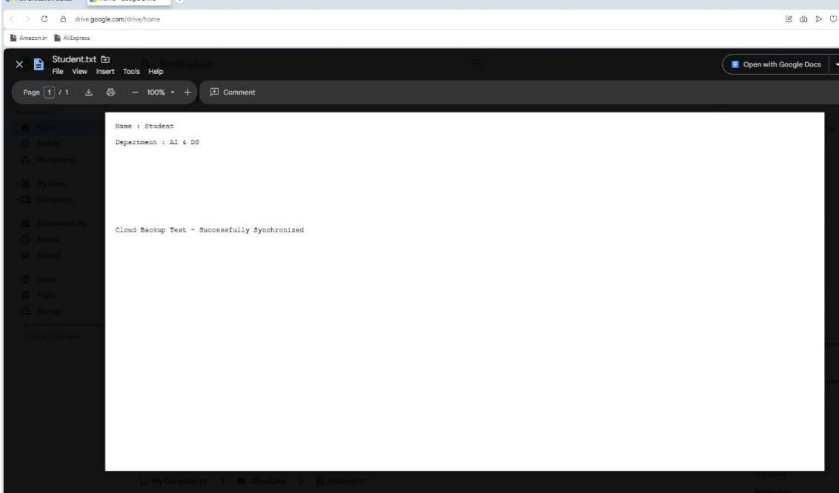
Figure 6: Contents of Student.txt in Google Drive, confirming the synchronized test line.

Conclusion
The cloud backup setup was successfully completed using Google Drive. Local files were migrated to cloud storage, automatic synchronization was enabled, and updates made to local files were successfully reflected in the cloud — demonstrating an effective and reliable cloud backup mechanism.

